**PORTFOLIO PROJECT**

IT Asset Management Project

Ismail Elmaliki

ITS 400 – Introduction to Project Management

Colorado State University – Global Campus

Dr. Chris den Heijer

June 08, 2018

Project Charter

|  |
| --- |
| **Project Title**: IT Asset Management System Project |
| **Location**: 3437 Shinn Street, New York, NY 10019 |
| **Intro**: At Wayne Insurance, our goal is to revolutionize the healthcare industry by providing world-class customer service and being transparent about our healthcare to customers. Our IT department at Wayne Insurance empowers us to reach our full potential as employees by being equipped with the latest technology. By considering an IT Asset Management system, it’ll ensure we’re continually investing into IT while keeping track of our spending. |
| **Project Goal**: The goal of this project is to have an IT Asset Management system in place that will keep track of all existing IT inventory (computers, printers, software licenses, computer accessories) while syncing with our current internal systems and being able to provide accurate information to our finance department with regard to spending. |
| **Expected Project Outcome**: By being able to complete this project and having that IT inventory system in place, here’s a preview of some of the benefits:   * Accurately tracking warranty information for our gadgets so they’re repaired by the manufacturer at ***no cost to us*** * Spending only 30 minutes to an hour a week instead of 4-5 hours a week updating inventory via an Excel spreadsheet – this means ***more time for IT staff to innovate*** * Ensuring accurate IT inventory – that way data can be easily shared with the financing department * By having accurate inventory in place, ***it’ll lead to less unnecessary purchases*** – that means IT can spend more time and money on areas that can be improved instead.   These benefits in the long-term will save the company money and time – especially for IT staff so we can focus on the tasks that matter! |

|  |
| --- |
| **Timeline** |
| **Resources Required**: The following resources are to be gathered and analyzed in order to choose an appropriate IT asset management system:   * Current internal IT systems * List of current IT equipment from internal systems * List of all software licenses used currently in the company |
| **Approximate budget**: $3000 annually |
| **Communications**: Here are the following individuals that will be involved:   * Lucas Mario - CEO * Warran Al – CTO and project sponsor * Russell Fowler – IT Director and project sponsor * Ismail Elmaliki – Project Manager * Chi Huang – Senior IT Engineer * Mike Anderson – IT Engineer * Jerry Santos – Senior IT Technician |

**Scope Management Plan and Work-Breakdown Structure (WBS)**

As defined by Kathy Schwalbe in Information Technology Project Management (2016), project scope management includes processes involved in defining and controlling what work is or is not included in a project. The following points of scope management (p.184-185) will be highlighted along with actions responding to each of these points regarding our IT Asset Management Project:

1. Process for preparing a detailed project scope statement.

* *Ensure all requirements are considered such as integration with JAMF Pro and Google’s G-Suite*

1. Process that enables the creation of the WBS from the detailed project scope statement

* *Smartsheet since it's integrated into our Google environment. Using it to create a Workspace and share the WBS among our colleagues*

1. Process that establishes how the WBS will be maintained and approved

* *Smartsheet has the capability of sending approval requests. All approval requests must be submitted if changes are to be made to WBS.*

1. Process that specifies how formal acceptance of the completed project deliverables will be obtained.

* *Weekly updates within Google Docs (1-page) that summarizes weekly project updates as well as what steps have been taken to make those necessary adjustments - due every Friday.*
* *2 30-minute weekly standup meetings (on Mondays and Wednesdays - discussing project status, where are we at, and how we can help one another adhere to deadlines).*

1. Process to control how requests for changes to the detailed project scope statement will be processed.

* *Request for approval in Smartsheet - having weekly 30-minute one-to-ones with all of my colleagues involved in executing this project.*

**Collecting Requirements**

|  |  |  |  |
| --- | --- | --- | --- |
| **Action** | **Description** | **Requirements** | **Priority Level** |
| **Requirements Analysis** | *Break down of category* |  | **!** High  **−** Medium  **⇓** Low |
| Functional Requirements | *What tasks does it perform?* | 1) Must be a dynamic asset management system that allows customization with an easy to use interface. 2) Administrator access to our IT team to ensure consistent workflow; adjusting access as necessary. |  |
| Timing | *What are the driving dates?* | 2 weeks to make sure IT asset management system being tested fulfills entire requirements checklist. |  |
| Service Requirements |  |  |  |
| Professional Services | *How reliable and up-to-date will this asset management system be?* | Must be modern interface with a ton of functionality. Asset management system must also take pride in constantly staying up to date and finding more intuitive ways of simplifying IT asset management. |  |
| Service & Support | *Is customer service top-notch and up to our standards as a healthcare company that's revolutionizing the industry?* | Excellent customer service must be a standard with this asset management company as well as transparency. It's a trait we embody as 21st century healthcare company. |  |
| Training & Documentation | *Are there available resources to learn about this asset management app inside out?* | Video tutorials and documentation; they must constantly be updated. |  |
| Technical Requirements |  |  |  |
| Data Requirements | *What information does it need and produce?* | Warranty information, financial information, vendor information, and internal system integration statistics. Also employee information. |  |
| Compatibility/Portability | *What are compatibility requirements from an IT point of view based on our infrastructure and existing technology?* | 1) Must be cloud-based to ensure it's continually backed up, 2) HIPAA compliant, 3) Integrate with G-Suite and JAMF Pro, 4) API available for seamless automation, 5) Bulk imports using a CSV, 6) Mobile apps to easily scan IT assets. | **!** |
| Maintenance | *Will it be easy to maintain from an IT workflow standpoint as we're continually adding more and more assets?* | 1) API availability for automation of repetitive tasks, 2) Mobile app to easily scan assets, 3) Seamless integration within the next few years as more and more assets are added | **!** |
| Security |  |  |  |
| System Confidentiality |  | Making sure information is kept confidential. Knowing encryption standards that are used to keep our data safe. Meeting HIPAA compliance. | **!** |
| Testing | *Requirements to assure quality.* | Must offer a free trial for at least one-month. |  |
| Performance Requirements |  |  |  |
| Precision / Accuracy |  | Data must be pulled accurately from JAMF Pro and G-Suite. | **!** |
| Reliability & Availability |  | At least availability & reliability of 99.99% |  |
| Capacity and Scalability |  | Must support 1000+ devices and counting | **!** |
| Future/Deferred Requirements |  | Elasticity and scalability as we have more and more devices added. |  |

**Scope Statement**

Identifying an IT asset management system to meet our requirements, then integrating it into our existing internal systems and into our workflow using asset tags on existing and new IT inventory moving forward.

**Work-Breakdown Structure**

The WBS for this project was developed using Smartsheet – a project management tool that includes many available templates as well as features like resource allocation, comments, approval requests, and many more collaborative features that make it easy to organize any project. Four photos are included below here: the first two are screenshots of the WBS while the next two are screenshots of the entire Gantt chart (photos can be zoomed into for clarity).

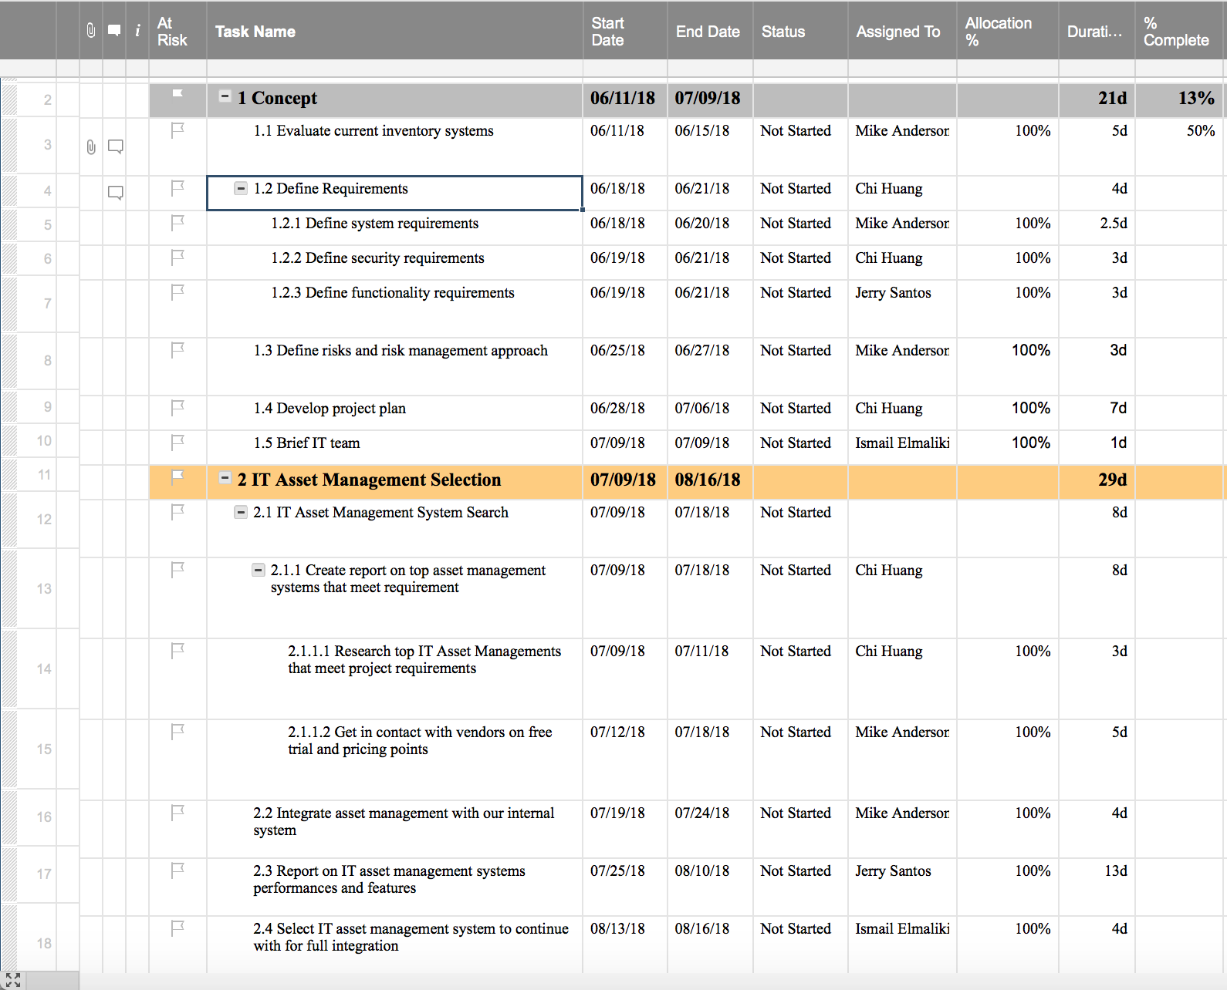

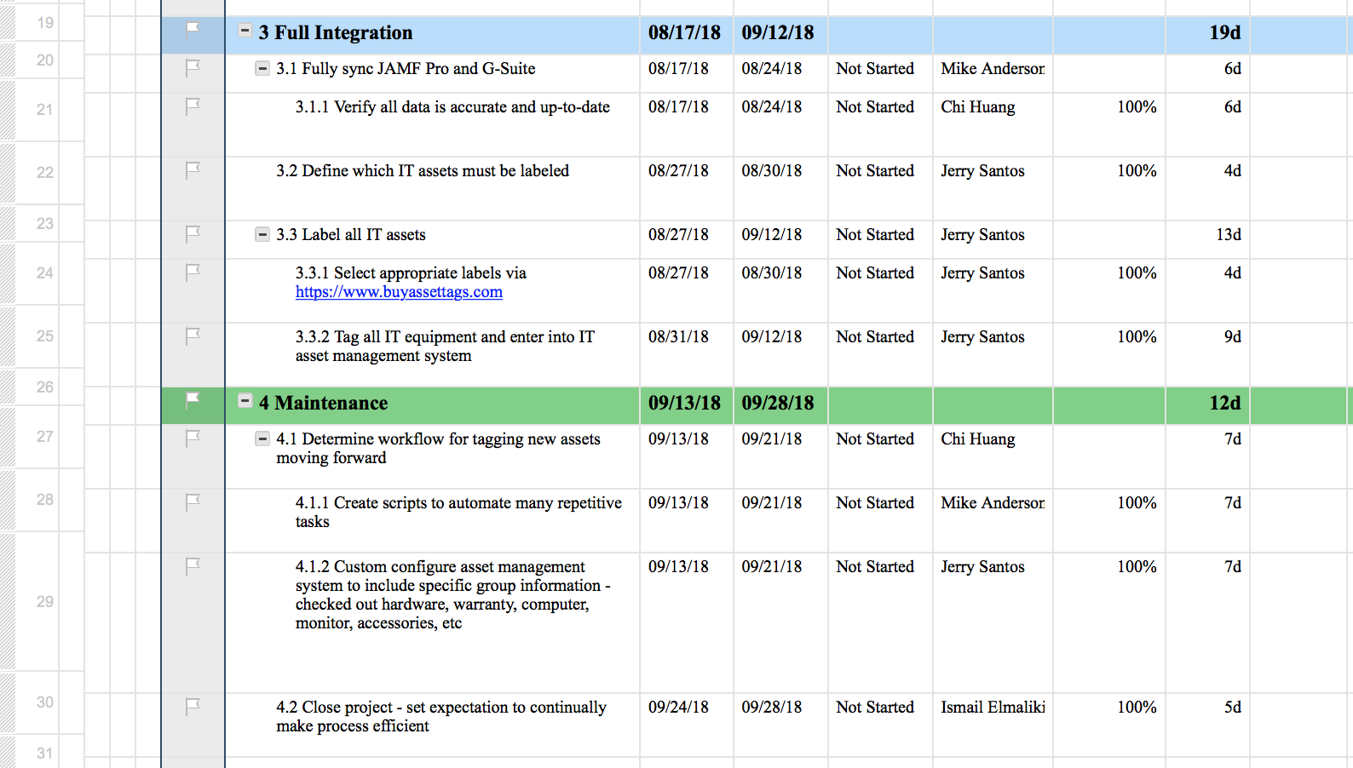

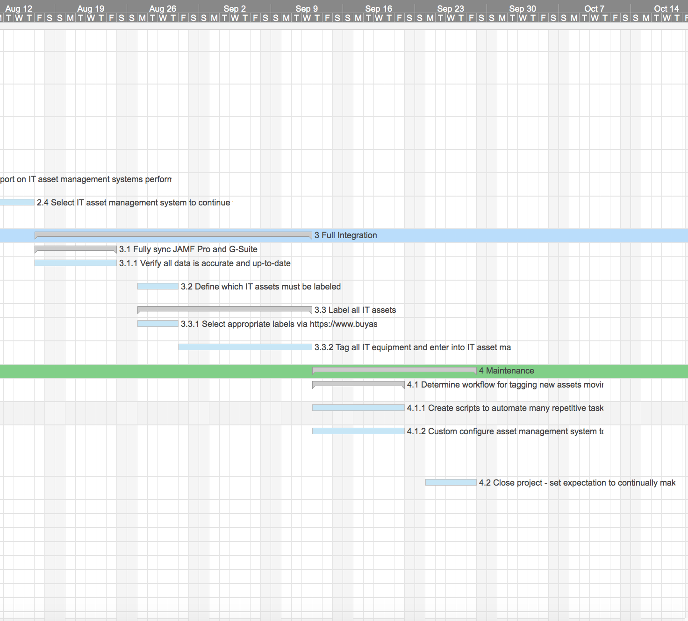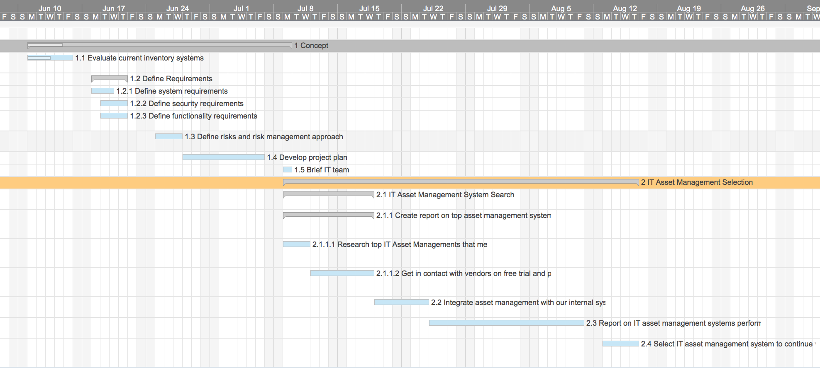

**Scope Control and Management**

Throughout the course of this project, communication will take place between myself and my colleagues during stand-ups team meetings and one-to-one meetings. Team meetings will take place for 30 minutes every Monday and Wednesday, while one-to-one meetings will be Monday through Thursday (each day representing one of my colleagues) for 30 minutes. In addition, Smartsheet will be utilized as a tool to reference our requirements checklist and keep track of our assigned task from the WBS. If changes are requested for any reason, we’ll be referencing our requirements as documentation for us to stay within scope and not take on more than we can handle.

**Communication Management Plan**

As mentioned previously in the scope control and management, two team meetings every week and 30-minute one-to-ones with colleagues will take place. Going into further detail on team meetings, this will be led by me in which I’ll be assessing the current status of our project per our WBS; getting to know where’s each individual in terms of tasks and how can we support one another to adhere to those deadlines. On top of that, my colleagues will need to submit a one-page weekly progress report that’ll be due every Friday. I will also be reporting to stakeholders that committed to this project with a monthly status report of our IT asset management project.

As far as a project management app, we’re utilizing Smartsheet. The beauty about Smartsheet is that it has many collaborative features. One feature that’s definitely being utilized is workspaces. According to a Smartsheet knowledge base article titled Create and Brand Your Workspace (2018), workspaces allow you to share multiple sheets at the same time. For example, we’ve utilized a workspace in Smartsheet so far to share our WBS and Requirements Checklist. Going further, if a colleague of mine would like to indicate he has completed a task from our WBS, he must request my approval. Rather than finding me and trying to reach out to me via email or instant messaging, he can just send me an approval request. From there, I’ll be able to respond instantly and either approve it or provide him constructive feedback on why I may not approve it just yet. Referencing another article from Smartsheet titled Approval Requests: Automatically Request Sign-Off on Work Items (2018), Smartsheet even has a feature to automate approval requests instead of my colleague manually clicking “Request approval” each and every time. For example, he can setup a rule in a specific column that indicates if he makes a change to that column, an approval request will automatically be sent to me. This and many other features within Smartsheet enables our workflow approval so I’m continually on the same page with my colleagues outside of meetings and our one-to-ones.

**Project Risk and Change Management Plans**

It’s extremely important to have long-term perspective and consider the risks of any project – both negative and positive. For negative risks that have the highest impact on any project, taking proactive steps to plan out a project diligently while having change management plans in place is the first and strongest step to take. With that said, here’s a negative risk below along with a positive risk of our IT asset management project:

*No.:* R101

*Rank:* 1

*Risk*: IT Asset Management Software Selection

*Description*: Because this project involves our IT team investing in an IT inventory management system software, it’s extremely important the project stakeholder, team members, and key stakeholders all chime in together and select an app that’s best suited for company IT needs so we can proceed with fully integrating asset management into our workflow. If it turns out we choose an IT inventory management system without due diligence, then it’ll delay the estimated project completion date and will cost the company both time and money.

*Category*: Financial and Structural risks

*Root Cause*: Choosing an IT inventory asset management system without fully assessing our requirements based on current systems we’re using today; jumping to a contract with a vendor without trialing their IT asset management solution beforehand to determine if it suits our needs.

*Triggers*: Difficulty using the IT inventory asset management system with our current IT systems in place like G-Suite and JAMF Pro such as inaccurate metrics and not auto-populating information properly. Also failing to put together a workflow because of system limitations from the IT asset management system.

*Potential Responses*: Communicating with vendor during free-trial on how we can access video tutorials and how-to articles; spending time gathering as much information as possible to ensure knowledge consistent with the IT inventory asset management app is applied with our current systems to populate accurate information.

*Risk owner*: Senior IT Engineer

*Probability*: Medium

*Impact*: High

*Status*: Project manager will communicate with Senior IT Engineer and IT Engineer during weekly one-to-one meetings and during weekly team meetings.

*Positive Risk*: Contracting with the right IT Asset Management company which will lead to a ROI (Return on Investment) because of its seamless integration and being able to adopt it into IT workflow within a short period of time.

*Triggers*: IT Engineers involved are easily able to use this inventory management system with our current IT platforms and use the IT Asset system’s API as necessary to automate repetitive tasks with ease. In addition, our IT technician will easily be able to integrate this system into his workflow and save a lot of time!

*Status*: Project manager communicating with team during one-to-ones and team weekly meetings.

Now that we identified risks, it’s important to have a plan in place to respond appropriately while taking preventative measures. With our WBS (Work-Breakdown Structure) in place using the Smartsheet online website to collaborate with our colleagues, we’ll be using its **request approval** feature. For example, if an IT Engineer needs to change his current sub-task based on difficulties with the IT asset management system or requiring more time, then he would need to **request approval** – this is sent to the project manager for review and will either be accepted or require further information in person via one-to-one or team meetings before considering the change. Also, setting up a brainstorming with my colleagues so I can receive their input on other possible risks of undergoing this project would help identify even more risks.

**Quality Management Plan**

We know as described in Information Technology Project Management (2016) that project quality management ensures “that the project will satisfy the needs for which it was undertaken” (p. 302) – meaning that the end goal of a project is to deliver a quality product or service that meets all requirements. With that said, we’ll be identifying each step of the quality management plan then identifying how we’ll be implementing it into our project:

1. Plan quality management
   * Time it takes to update IT inventory on a weekly basis.
   * Updating documentation on IT asset management workflow via Google Team Drive.
   * Monthly export of newly added inventory and ensuring it’s up to date - creating a quality checklist.
2. Project quality assurance
   * Weekly report submitted by employees during this project, especially during the maintenance phase.
   * Reviewing monthly export and ensuring it’s consistent with new inventory that came in as per our invoices.
   * Any changes made must be submitted to project manager for approval as per Smartsheet workflow.
3. Perform quality control
   * IT Engineers taking ownership on a monthly basis to continually stay up-to-date with knowledge on inventory management system while applying automation to make many repetitive actions as efficient as possible.
   * Once our project is closed, having bi-weekly meetings for the first two months on how we can continually improve the asset management workflow. Then having a meeting once a month to ensure we’re continually making an effort to improve our IT asset management system workflow.

**Project Closure**

Although this project hasn’t yet started, I expect by the time this project is closed out that my project management skills will grow exponentially. In addition, learning about many of our internal systems at both a high-level and low-technical level which will give me more confidence to lead even more projects after this. Another key learning opportunity is how to select an IT system that meets our requirements while considering the workflow of my colleagues as IT Engineers and IT Technicians. We had discussions prior to starting this project and one IT asset management system we may have in mind is Asset Panda. Many of our questions were answered from Asset Panda’s facts page (2018), but it’s important we stick to our requirements and move on to a free trial (that’s if every requirement is matched). Wrapping things up here, as a project manager, my goal is to engage my colleagues and lead our communication – that way we continually plan and carry out our execution while being on the same page every step of the way. There’s an old saying that rings true every time – if you fail to plan, you plan to fail. In the world of project management, this especially rings true and spending that extra time planning will save us time to execute our tasks more efficiently.

References

Approval Requests: Automatically Request Sign-Off on Work Items. (n.d.). Retrieved June 6,

2018, from Smartsheet website: https://help.smartsheet.com/articles/2476591-working-with-approval-requests

Create and Brand Your Workspace. (n.d.). Retrieved June 6, 2018, from Smartsheet website:

https://help.smartsheet.com/articles/506687-creating-branding-a-workspace

FAQs. (n.d.). Retrieved June 6, 2018, from Asset Panda website:

https://www.assetpanda.com/faq/

Schwalbe, K. (2016). Information Technology Project Management (Eight ed., Vol. 8e). Boston,

MA: Cengage Learning.